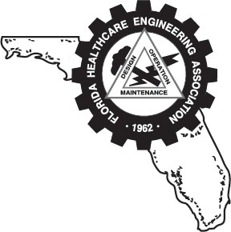
FLORIDA HEALTHCARE ENGINEERING ASSOCIATION

Webinar Presentations

The FHEA is accepting educational webinar presentations. Topics should be directly relevant and of interest to our core member group, Florida’s healthcare facility management professionals, and must relate to one or more of the categories listed below.
Presentations must be strictly informational and in no way promote your company’s products or service offerings.

*Presentations must be 60 minutes in length. To qualify for approval of ASHE CE credits, programs must relate to the content outline categories of the CHC or CHFM which include Compliance; Planning, Design, and Construction; Maintenance & Operations; Finance; Administration; Healthcare Industry Fundamentals; Healthcare Facility Safety- Additions & Renovations; and/or Financial Stewardship.

Presentation Title Presenter Name Presenter Title Company Work Phone _______________________________ Cell Phone _________________________________
Email
Proposed date(s) and time: _______________________________________________________________________
As a separate document, please attach and include the following materials:

- *Topic Content Category_____________________________________________________
- Presenter Resume/CV that includes educational history and background; all qualifying experience; and publications (if applicable)
- Presentation summary and learning objectives: Summary and four bullet points of what audience will take away from the webinar.
- Descriptive Timed Presentation Outline with Bibliography Reference page of source materials – the outline must explain and describe the specific topic content as well.

Submit completed form, additional pages with the materials and information, as listed above in items 1-4 via email to the FHEA Office, info@fhea.org

Florida Healthcare Engineering Association 11812 N. 56th Street, Tampa, FL 33617 813.988-FHEA - www.fhea.org

